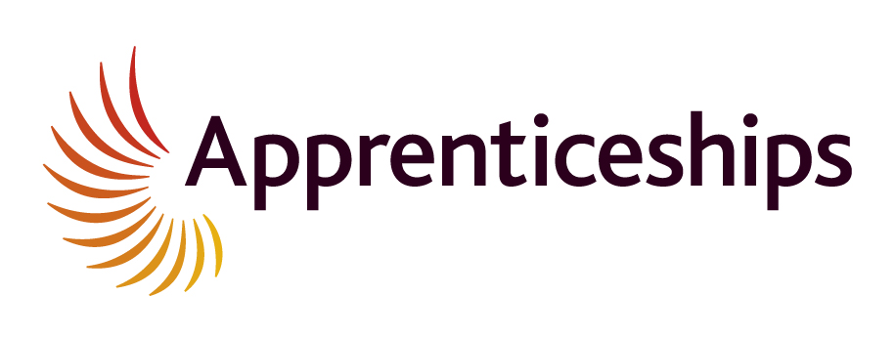

Customer Service Apprenticeships – Level 2

Hours of work – Core business hours between 9am and 5pm

Hourly Rate – £5.28

Holidays – 24 days’ paid holiday per year as well as bank holidays.

Your Homes Newcastle (YHN) manages homes on behalf of Newcastle City Council (NCC). As well as looking after properties, we also provide a range of services that support our customers both young and old. To find out more about what we do, visit @newsfromYHN or www.yhn.org.uk.

Eligibility
As part of the recruitment process, priority will be given to applicants who live in a YHN home.
If you have already been employed by YHN as an apprentice or trainee unfortunately you will not be eligible to apply for this programme.

About the role
This is an exciting opportunity to develop your customer service and administration skills whilst working for a large local organisation. Your role will involve providing support to one of the many different teams that we have at YHN. You could be working for our Housing Plus Team keeping records up to date and talking to some of our more vulnerable customers, supporting our Safe Living Team who manage anti-social behaviour cases, or you could be working in our regeneration team supporting the work they do in improving properties and estates. The types of tasks you could be involved in include:

- Speaking to customers, either face to face, over the phone or by email, taking information in terms of their queries and needs
- Providing information to customers about the services available to them and how we can meet their needs
- Providing a range of administrative support and services to the appropriate team
- Maintaining accurate records and information
- Managing e-mails, calendar appointments, filing and typing as required
- Answering the telephone
- Dealing with enquiries from both internal and external customers
- Assisting with sending information to customers and staff
- Assisting officers at YHN events
- Participating in the Apprenticeship training and achieving all qualifications

About the person
We are not looking for someone with lots of experience, however you will need a good level of literacy and good communication skills.

We will be looking for someone who can demonstrate the following skills and behaviours:
- A self-starter who is motivated to succeed both in the workplace and in passing the associated qualifications
- Ability to set and maintain excellent levels of timekeeping and attendance
- Good level of customer service (polite, friendly, helpful)
- Good level of literacy and good communication skills
- Able to plan and work to deadlines
- Good teamwork skills
- Basic Microsoft Office skills (in particular, Word and Excel)
- Ability to work independently and using own initiative
- Able to work in a professional manner in an office environment in accordance with YHN’s core values
- Able to maintain and understand confidentiality

